How to leave us a Google+ review

Thank you for choosing COMPANY NAME for your PRODUCT/SERVICE needs. We value your custom so if you have any feedback please let us know by contacting us on TELEPHONE/EMAIL.

If you have a moment, we would appreciate it if you could leave us a Google+ review. Reviews help us to improve our service and others to make purchasing choices.

To leave a review, please follow the quick and easy instructions below (estimated time: 60 seconds).

How to submit a Google+ review:
Click Here
- Login - with any Google account (Gmail, Android, and YouTube etc.)
- Select a "Star Rating"
- Leave a comment (optional)
- Click "Publish"
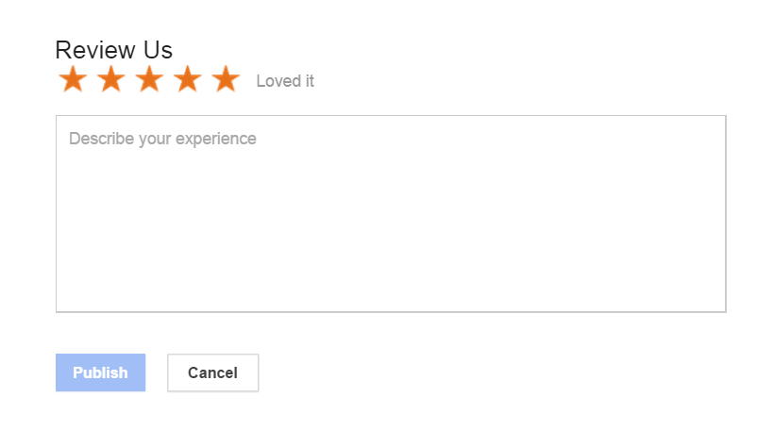
Thank you for your time.

For more information see our blog post.

